|  |  |
| --- | --- |
| cetlogo ***CHEMICAL ENGINEERING TRANSACTIONS***  ***VOL. xxx, 2025*** | A publication of  aidiclogo_grande |
| The Italian Association  of Chemical Engineering  Online at www.cetjournal.it |
| Guest Editors: Bruno Fabiano, Valerio Cozzani, Ales Bernatik  Copyright © 2025, AIDIC Servizi S.r.l. **ISBN** 979-12-81206-xx-y; **ISSN** 2283-9216 | |

Uncertainty Quantification In Industrial Risk Assessment For Practical Decision-Making

Nelly Olivier-Maget, Thibaud de Barnier, Florent Bourgeois, Nadine Gabas

Laboratoire de Génie Chimique, Université de Toulouse, CNRS, INPT, UPS, Toulouse, France

nelly.olivier@ensiacet.fr

Quantitative risk analysis has become an essential decision-making tool for all industrial activities exposed to major accidents. One way of improving the benefit of quantitative risk analysis in practice is to account for the uncertainties inherent in the probability of occurrence of events and scenarios likely to occur. Indeed, in the near future, it seems inevitable that decisions will be made based on results from risk analyses with uncertainties. The bowtie method is no exception to this necessary evolution. The use of the results of this type of analysis by decision-makers requires a significant change in practice, since they lead to a probability distribution of the probability of occurrence of an event or scenario, and no longer to a simple average value that can be directly transferred to risk matrices. This article is a contribution to this predictable evolution, which raises the question of the relevance of a suitable graphical representation as an aid to decision-making. The proposed solution is a probability class-based histogram, which yield an unambiguous projection the results from a risk analysis with uncertainties onto regulatory risk matrices.

* 1. Introduction

After being ignored for a long time, the introduction of uncertainties in industrial risk analysis has been the subject of serious studies for more than a decade (Pasman and Rodgers, 2018). The results of analysis with uncertainties are generally communicated to decision-makers and stakeholders as part of the complete risk analysis process. Indeed, the ultimate objective of a risk analysis is to decide whether the potential accident scenarios highlighted are within an acceptable or even tolerable zone and, if not, to determine how to remedy the situation by putting in place safety barriers. Given that the decisions often concern investment projects, the issues are important and the situation can be tense. Taking uncertainties into account in the analysis should be seen as a way to reduce decision-making risks. However, these days it is still common for decisions to be conservative under the pretext of a traditional defence-in-depth engineering approach. This article discusses some challenges of using the results of industrial risk assessment with uncertainty in practical decision-making.

* 1. State of the art on decision-making under uncertainty

In a world of constant change and unpredictability, the ability to make informed decisions in situations of uncertainty is more essential than ever. The aim of this section is to present the state of the art in theoretical and empirical research on this complex subject in the context of applied industrial risk management.

* + 1. Behaviour in decision making

Risk analysts generally aim to transform their knowledge into probability data, which can be combined to yield the probability of occurrence of events that have an impact on decisions. It should be noted that the results of risk analyses are tainted by a certain amount of ‘subjectivity’, as they are partly dependent on the assumptions made, and other analysts may conclude differently. However, decision-makers rely on these studies because they know that it is the analysts who have the expertise in the field under study (Aven, 2010). According to Aven and Zio (2011), the results of technical studies represent only part of the information needed for decision-making. Furthermore, for these results to be taken into consideration by decision-makers, the methods and assumptions made must be clearly stated and shared with them. Apostolakis (2004) summed up these considerations with the quote ‘the decision-making is risk-informed, not risk-based’. Zio and Pedroni (2012) noted that decision-making can be strongly influenced by a country's social, economic and cultural context. Thus, the level of acceptability of a risk associated with a given process, say in the nuclear or chemical industry for example, will differ from one country to another. It should also be remembered that decisions taken by groups can be influenced by factors such as conservatism or the phenomenon of group polarisation, i.e. the tendency of people in a group situation to take more extreme or riskier decisions than when they decide alone.

* + 1. Links between uncertainty accounting methods and decision-making

There exist several methods for quantifying uncertainty in risk analyses. They account for uncertainties in specific ways and potentially lead to different decisions. Thus, in a given context, the use of an inappropriate method may lead to underestimating or overestimating risks and, consequently, to unsatisfactory decisions (Abdo et al., 2017). Aven and Zio (2011) and Abdo et al. (2017) reviewed the different methods of taking uncertainty into account, examining the advantages and disadvantages of each from a decision-making perspective. Probabilistic only approaches are currently the most widely used in the process industry, considering their simplicity in principle and implementation and the availability of probability-based risk simulation software. Probability approaches have drawbacks however. For example, Abdo et al (2017) note that if the data on which the probability distributions are based are imprecise (e.g. a measurement precise of the probability exists but is not perfectly known), the approach may be non-conservative, which may lead to underestimation of the decision-making risk. Aven and Zio (2011) recommend that probabilistic approaches should continue to be used, provided that relevant statistical data are available, as their results are simple to interpret and can be strengthened by sensitivity analyses. They suggest that decision-makers should rely in parallel on qualitative assessments by experts to ensure that they are not misled by outlying results. When there is insufficient data to implement the probabilistic method, it is necessary to resort to the fuzzy logic or Dempster-Shafer belief functions, noting that their interpretation and practical use are not as readily interpretable and useable by decision-makers. Aven and Zio (2011) and Abdo et al. (2017) propose to implement a hybrid method where random uncertainties are treated by probability distributions and epistemic uncertainties by fuzzy numbers. Decisions are then based on a combination of probabilistic and fuzzy data. While this combined approach is probably the most promising solution for capitalising on existing data for risk assessment, it represents a major step forward in terms of complexity and poses a major challenge for practical risk quantification by decision-makers. Before resorting to this approach, and so as to lead to the practical and systematic use of uncertainties in industrial risk assessment, an intermediate step consists of converting all uncertainties, whether aleatoric or epistemic, into probability distributions.

* + 1. Representation of risk under uncertainty to aid decision making

Communication on uncertainty must be adapted to the users of this information. This does not mean that scientists should tell decision-makers what to do, but that they should provide them with useful information to help them make practical decisions. Thus, it is fundamental to their interpretation that the information be communicated in a format that decision-makers can understand. It must allow meaningful comparisons with quantitative safety criteria (such as acceptability thresholds or sensitivity tests) to be incorporated into the deliberative process. In order to identify the most effective strategy for reducing the risk through prevention and/or mitigation measures, the decision-maker relies not only on the classification of the risk (acceptable, ALARP or unacceptable) but also on the visual representation of the results. Citizens are also involved in collaborative risk governance, so they need to be provided with understandable, usable and verifiable risk information. Visual forms of risk communication have clear advantages over lengthy technical reports or tables of statistical data. They allow the public to easily explore complex risk data and play a more active role in the various stages of the risk management process. Where disaster risk management is controversial, for example because of differing perceptions of risk among different political actors, risk visualisations can help to provide a degree of objectivity. Roth (2012) recommends the use of coloured scatter and suggests the use of animations. Animated diagrams can be used by experts and easily integrated into public risk communication. However, risk communication should not be limited to visualisation without critical analysis or in-depth knowledge of visual techniques and their effects, which may suggest a false objectivity.

* + 1. Industrial point of view

In the context of our work, a symposium was organised with industrial partners to gather their views on the theme of “Assessing industrial risks under uncertainty and decision-making”. It took place thanks to the collaboration of Technip Energies company and ICSI French association. The symposium produced some following points with regard to the process for taking account of uncertainties in quantified risk analyses and the related decision-making processes:

* It is very rarely used in the fields represented by the symposium participants,
* It could be useful in areas where feedback is non-existent or highly uncertain, such as the development of new technologies (e.g. hydrogen technologies, decarbonation, CO2 capture) or where the initiating events are highly variable (e.g. human error), but not for ‘mature’ technologies. This practice makes it possible to estimate a confidence index for the results.
* It ‘blurs’ the boundaries between the cells in the risk matrix, which can improve the relevance of the decision, but requires interpretative skills.
* It would make it possible to study and visualise the sensitivity of a system's safety to variations in critical parameters.
* To be complete, the approach should also incorporate the uncertainties associated with the ‘severity of consequences’ dimension of the risk matrix.
* It is likely to be difficult to recommend this practice in sensitive areas such as nuclear field, where the approach is exclusively conservative.
* Project managers are not made aware of the ‘uncertainties’ involved in deciding on the feasibility of a project. The decision they have to make is whether it is feasible or not.
  1. Visual representation of risk to help decision-making

As part of our work on a fully probabilistic analysis of the bowtie method for decision-making in industrial risk analysis, we dedicated some efforts on the visualisation of probabilistic results. This section reports some of the associated developments.

* + 1. Visualisation of probabilistic risk for practical decision-making

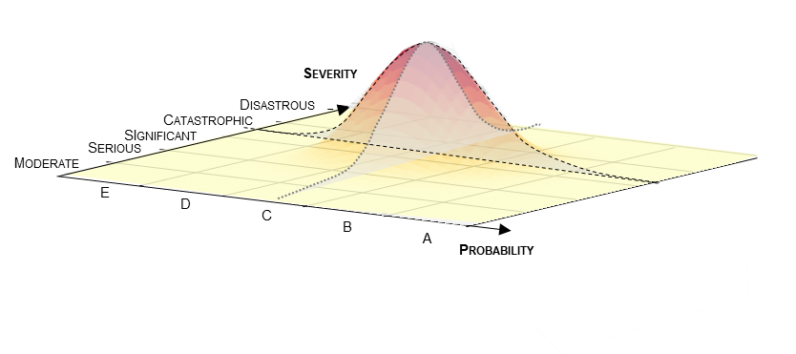

*Figure 1:* Visualisation of accidental risk in the risk acceptability framework with uncertainties

Our research has focused on a practical analysis of the resolution of the bowtie that integrates aleatoric and epistemic uncertainties linked to the events and safety barriers present in the bowtie (Barnier, 2024). The work chose to convert epistemic uncertainties into probability distributions, yielding a purely probabilistic risk quantification solution. In terms of risk visualisation, probabilistic risk quantification replaces the representation of a given risk as a point in a cell of the risk matrix (probability versus severity) by a two-dimensional probability distribution. Figure 1 illustrates the visualisation of an accidental risk in the risk acceptability framework, taking into account uncertainties in the probability and severity data (probability distribution). This example shows that the boundaries of the distribution ‘overflow’ from the different cells. For the purposes of this study, we take into account only the uncertainties associated with probability as a first step. These results clearly provide additional information compared with the ‘single point’ method, but we can ask ourselves how they can benefit decision-making, both in terms of reliability and ease of the decision. To assist in understanding and using the results of a probabilistic risk analysis with uncertainties using the bowtie method, it is interesting to represent a statistical distribution of the probability of occurrence relative to a consequence scenario or a feared event as shown in Figure 2. Compared to Figure 1, this only uses one dimension of uncertainty. On the left graph, the vertical dotted line shows the average probability of occurrence and A to E represent the 5 probability classes of the regulatory risk matrix. It should be noted that the horizontal scale, which is the probability of occurrence of a particular event, is logarithmic. On the right graph, a histogram shows the extent of the distribution of the probability of occurrence in percentage terms both in the probability classes (A to E) and in the zones of acceptability (acceptable in green / tolerable in orange / unacceptable in red). The horizontal dotted line represents a possible decision-making probability threshold. The probability class-based histogram appears to be a pragmatic way to communicate visually probabilistic risk evaluation results to decision-makers. In this example, the graph conveys visually that while the single-point (mean probability) risk analysis corresponds to the dotted line and falls in the risk class C, nearly 5% of the risk overflows in risk class B. Such a visual representation of probabilistic risk is simple and yet brings significantly more valuable information to the decision-maker than single point analysis.

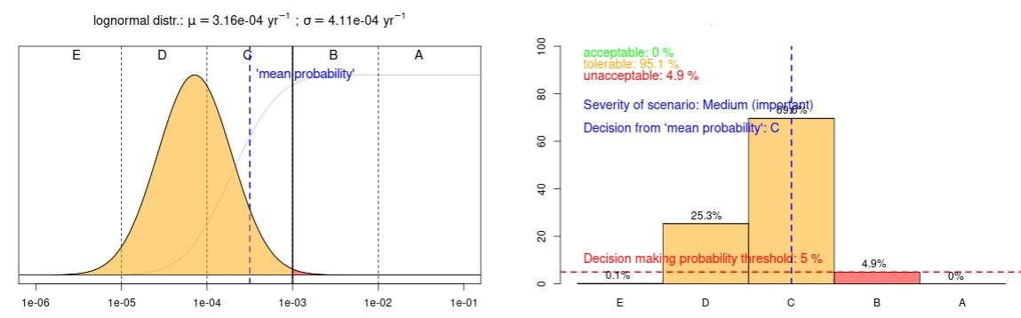

*Figure 2: V*isualization of risk under uncertainties for decision-making

The decision-making probability threshold remains the decision-maker’s prerogative evidently.



*Figure 3:* Density distribution of the probability of occurrence **on** logarithmic (left) and linear (right) scales

Of course, the probability density function shows the full probabilistic risk analysis output, However, visual interpretation can be misleading, whereas the histogram in Figure 2 eliminates any possibility of misinterpretation. The probability density functions in Figure 3 are identical, but they are plotted on logarithmic and linear probability axes, which can affect their visual interpretation and make it difficult to appreciate that the zones in a given risk class are identical in the two representations. In Figure 3, the probability of occurrence in risk class B is 41,7% in both representations. Suffice to say that the probability of occurrence in a risk class is always better appreciated on the linear scale than on the logarithmic scale.

The following section further explores the practical value of the probability class-based histogram as a decision-making visual aid through selected examples.

* + 1. Results and discussion

Let's consider 2 examples of distributions which have the same mean probability value but not the same coefficient of variation (CV or *Relative standard deviation (RSD)*), in order to illustrate the importance of the extent of data variability on the resulting decision-making.

* Distribution 1: case of a Lognormal distribution defined by:  = 3.16 x 10-4 and σ = 4.11 x 10-4, giving CV = 1.3
* Distribution 2: Lognormal distribution defined by:  = 3.16 x 10-4 (same mean value as distribution 1), and σ = 8.2016 x 10-4 giving CV = 2.6 (twice the CV of distribution 1).

It is possible to compare the histograms of percentages belonging to the probability classes (A to E) in the risk matrix (Figure 4). The mean value appears in both cases. To interpret the results, we have chosen a decision probability threshold for risk acceptability corresponding to a percentage of risk in the intolerable zone less than or equal to 5%. If we compare the distributions 1 and 2, which have the same mean value but not the same CV, we can see that, for the ‘catastrophic’ level of severity, the acceptability histograms are totally different (Figure 4. We conclude from this that the size of the range of uncertainty, 2 times greater for distribution 2 than for distribution 1, determines the acceptability of the risk. In fact, the ‘part’ of the risk in class B is 6.4% for the distribution A with a decision threshold chosen equal to 5%. This illustrates the fact that taking uncertainties into account provides decision-makers with additional information that justifies the actions to be taken to make the risk acceptable. The risk deemed acceptable by the ‘single point’ method is therefore underestimated. Uncertainties therefore increase the confidence that can be placed in the results of the analysis. Let's look at the case where most of the risk lies in the unacceptable zone. This is the situation corresponding to distribution 1 in Figure 4b. The mean value is also in the ‘red’ zone. The position in the matrix is not altered by taking into account the uncertainties in the input data. The decision-maker can therefore be fairly confident in this result and is completely convinced that the risk is unacceptable. There is a ‘real’ process safety problem. Faced with this problem, it is possible to consider, as a first step, going back over the bow-tie to ensure that the accidental sequences have been correctly transcribed and then considering the implementation of additional safety barriers.

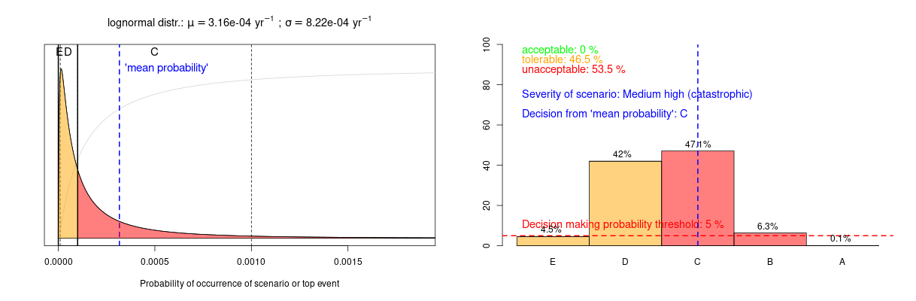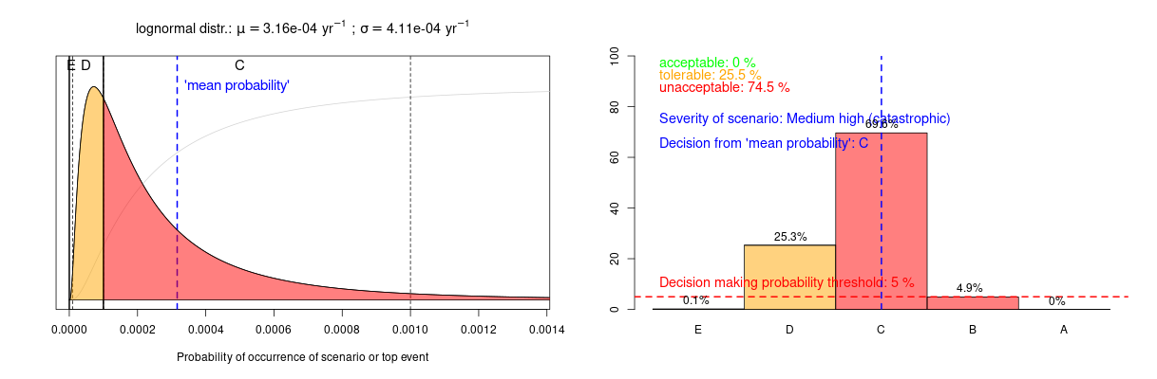  *(a) (b)*

*Figure 4:* Histograms of acceptability zones of distributions 1 (left) and 2 (right) for the castrophic severity level

Another interesting case is the situation where the probability distribution is fairly evenly distributed between the unacceptable and the tolerable zones. One may wonder where the average probability is in a tolerable or an unacceptable box (Figure 4a). In current practice, when the average value is within the tolerable zone, we must demonstrate that the reduction of risk to the acceptable zone is not feasible or that its cost is highly disproportionate to the improvement achieved. When it is in the unacceptable area, there is no other option but to add barriers. On the other hand, given uncertainties, if the average value is in the tolerable zone with about 50% of the probability distribution in the red zone, a safe approach would be to add additional barriers while keeping in mind that the probability is not entirely in the red zone. This new information can be useful in calibrating the performance requirements of additional barriers. This is where our approach is most interesting, because it allows for a reasonable decision to be made rather than an unconservative or overly conservative decision.

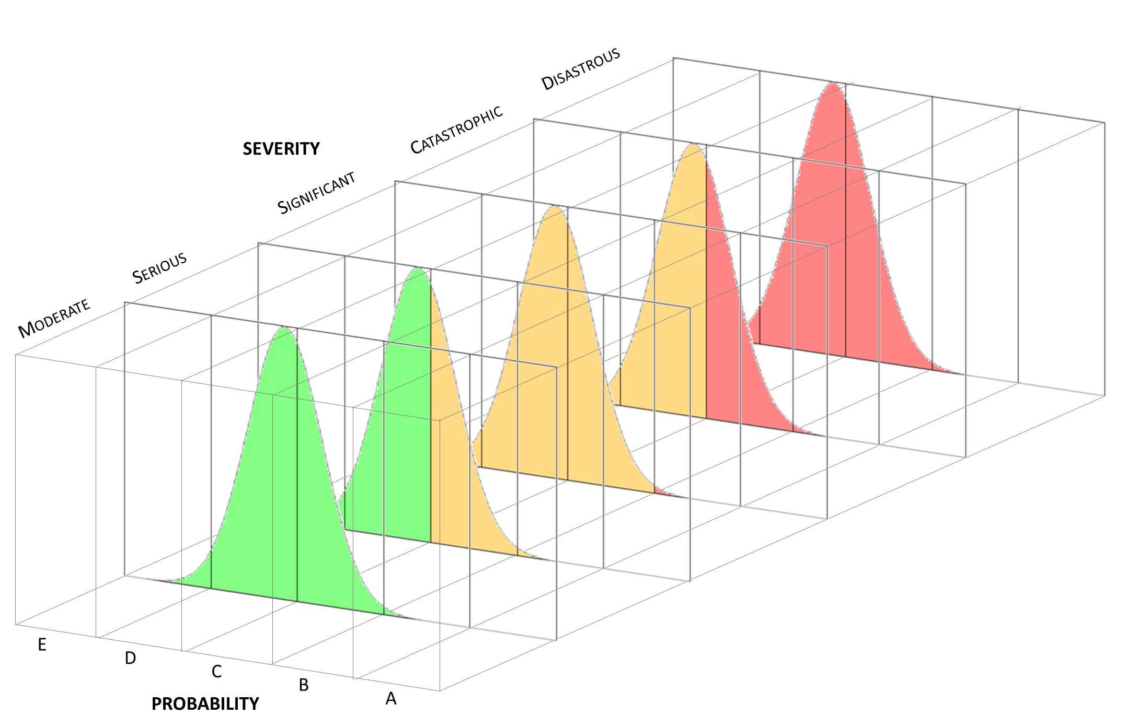

*Figure 5:* Visualization of the acceptability of distribution 1 according to severity classes

Figure 5 shows how severity uncertainty can affect decision-making. With the same uncertainties about our probability, we won't have the same acceptability, depending on the level of severity chosen. For example, if we consider the ‘important’ severity level, the risk is considered as tolerable (95,1%), whereas for the ‘catastrophic’ severity level the risk is considered as unacceptable (74.5%).

It is therefore essential to continue quantifying uncertainties about severity. The few situations we have just examined show that taking uncertainties into account does not lead to a more complex decision-making process. On the contrary, it can provide decision-makers with additional information to help them make decisions with a better understanding of the confidence that can be placed in probability values.

* 1. Conclusions

Uncertainties in industrial risk analysis are needed to make the best-informed decision. Their use, however, can add a degree of complexity and represent a practical obstacle for decision-makers. It therefore seems important to combine risk analysis under uncertainty with visualisation methods that facilitate the interpretation of results and, ultimately, decision-making. Since the results of the analysis with uncertainties produce a probability distribution for the occurrence of an event of interest, the challenge for this analysis to be taken up by decision-makers is to propose a visualisation method that transposes this distribution in an easily interpretable way into regulatory risk matrices. This work finds that the use of a probability class-based histogram is a simple way for projecting the results from a probabilistic risk analysis onto regulatory risk matrices, and hence should prove an effective visual aid for decision-making.

The organization of a symposium dedicated to the use of uncertainties in quantified risk analyses showed that the majority of participants expressed interest in the subject. They concluded it should be the way forward, even though this practice remains anecdotal amongst specialists. It emerged from this event that the field of new technologies, due to the absence of REX, is undoubtedly the one that would benefit most from the use of uncertainties in its risk analyses. Having shown that there are particularly simple methods for visualising the results of risk analysis under uncertainty, which eliminate the difficulty of interpretation for decision-makers, the challenge of this analysis remains to use the models that are most capable of capturing the degree of knowledge about the probability of occurrence of events in the industrial system under consideration.

Acknowledgements

The authors would like to thank Technip Energies for their support, the ANRT for their financial contribution, and Olivier Iddir for his valuable expertise.

References

Abdo, H., Flaus, J.M., Masse, F., (2017). Uncertainty Quantification in Risk Assessment - Representation, Propagation and Treatment Approaches: Application to Atmospheric Dispersion Modeling. J. Loss Prev. Process Ind. 49, 551–571.

Apostolakis, G. E., (2004). How useful is quantitative risk assessment? Risk Analysis, 24(3), 515–520.

Aven, T., (2010). On the need for restricting the probabilistic analysis in risk assessments to variability. Risk Analysis, 30(3), 354–360.

Aven, T., Zio, E., (2011). Some considerations on the treatment of uncertainties in risk assessment for practical decision making. Reliability Engineering & System Safety 96, 64–74.

Barnier (de) T., 2024, PhD Thesis, Institut National Polytechnique de Toulouse, France

Pasman, H., Rogers, W., (2018). How trustworthy are risk assessment results, and what can be done about the uncertainties they are plagued with? Journal of Loss Prevention in the Process Industries 55, 162–177.

Roth, F., (2012). Visualizing risk: The Use of Graphical Elements in Risk Analysis and Communications. ETH Zurich.

Zio, E., Pedroni N., (2012). Overview of Risk-Informed Decision-Making Processes. Cahiers de la Sécurité Industrielle. 2012-07. FonCSI. France (ISSN 2100-3874).